Bacon Wrapped Jalapeno Poppers

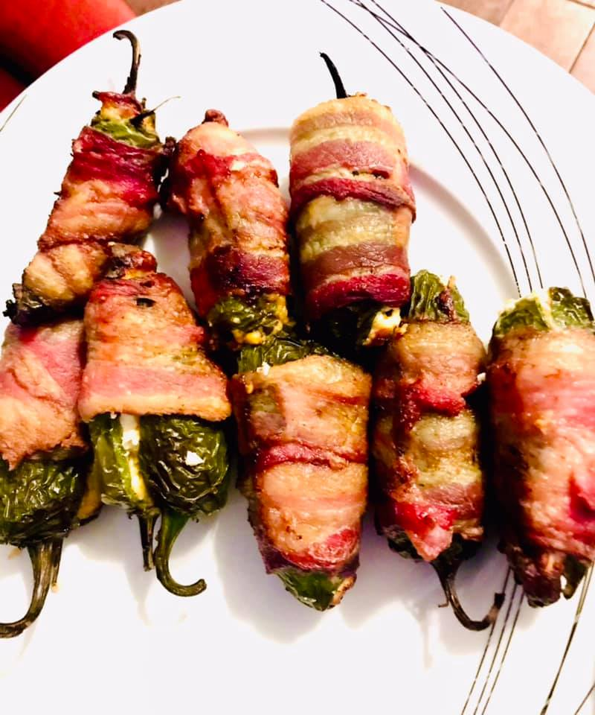

So, it was new years eve. As pandemic times continues, this year, New Year’s Eve has been just family parties for most of us following covid protocols. Our family of 3 had a quiet celebration. But we made sure we made a lot of yummy snacks as we watched "Ugly Delicious" on Netflix into the new year’s! Try this easy starter snack which will be a favorite among kids and adults equally!

Ingredients

* Jalapeno peppers 8
* Thin cut bacon strips 4 or as needed
* Cream cheese as needed for filling
* Cheddar cheese as needed for filling

Air Fryer Method:

Bring the cream cheese out of the refrigerator to room temperature so it becomes soft. Split the jalapeno peppers into half. Scoop away the seeds and vein.  Fill the peppers with cream cheese and cheddar cheese.



Cut bacon strips to half. Wrap the bacon around the peppers.

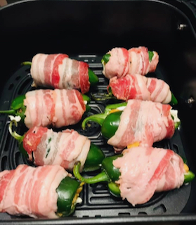

Air fry at 400 deg F for 10 minutes.

Oven Method:

Preheat oven to 400 deg F and bake for 15 minutes.

**Notes**: 1.The cheese filled pepper halves may be joined together and then have bacon wrapped around it or bacon can be wrapped on each half pepper separately.

2. Air frying time depends on how crispy or soft you want the peppers to be done. It can be done anywhere between 8 to 15 minutes. The more time the softer the peppers get.

3. If needed, salt and pepper can be added on top of the cheese filling. But bacon is very salty already and peppers are spicy, so go easy on it.

4. Vegetarians can make the poppers with thin slices of zucchini or potato ribbons instead of bacon.